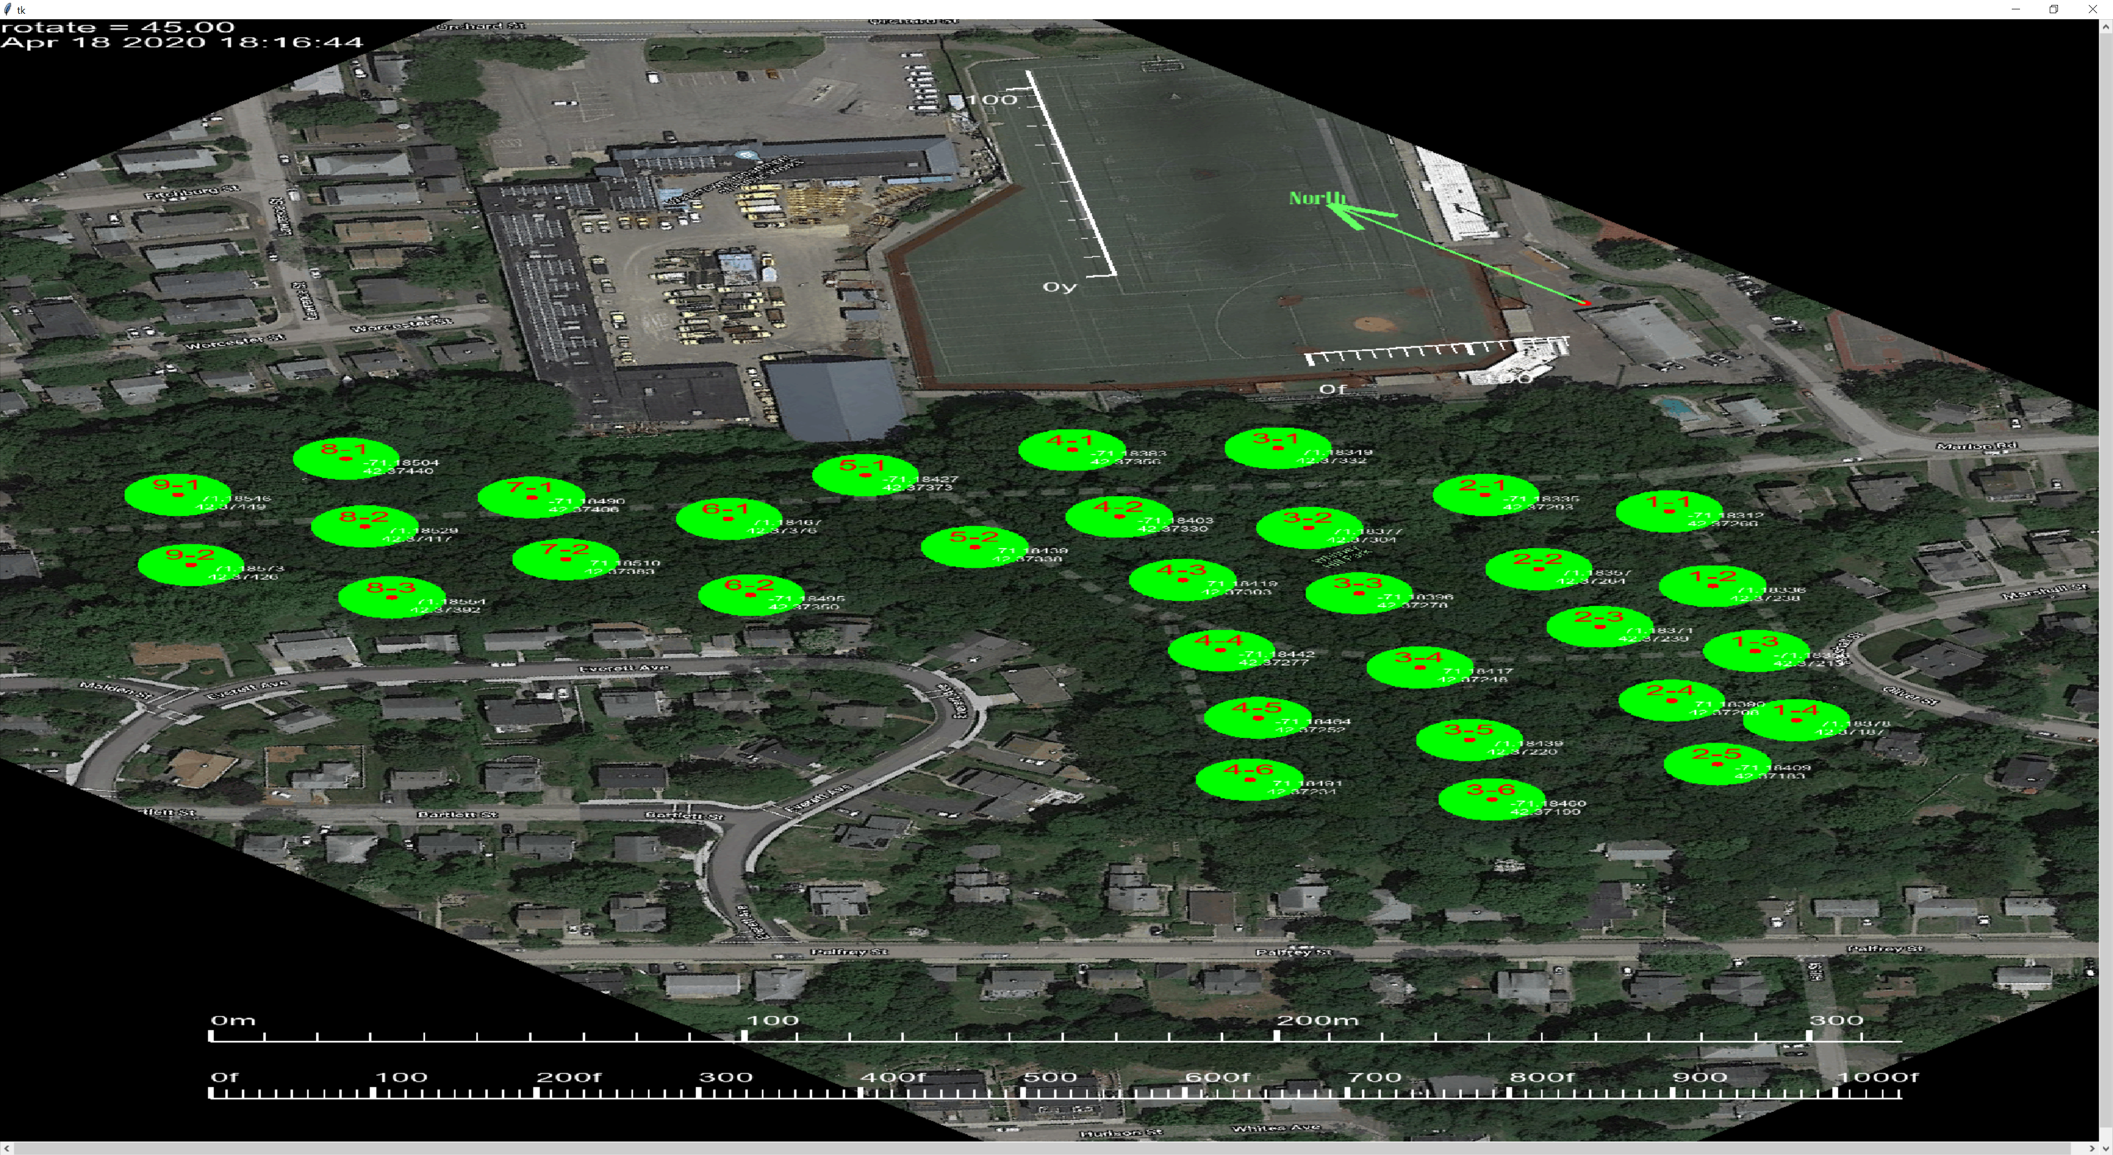

I'm guessing about where the arrow points. Can you indicate with greater precision where the TBM point is. For example is there a physical feature you can point out on the image?